SPI_Polling(*Serial Peripheral Interface)*

Configuration in STMCUBEMX:

1.Select SYS->serial wire.

2.Select SPI1 ->select full duplex master.

3.Make the following changes in pinout.

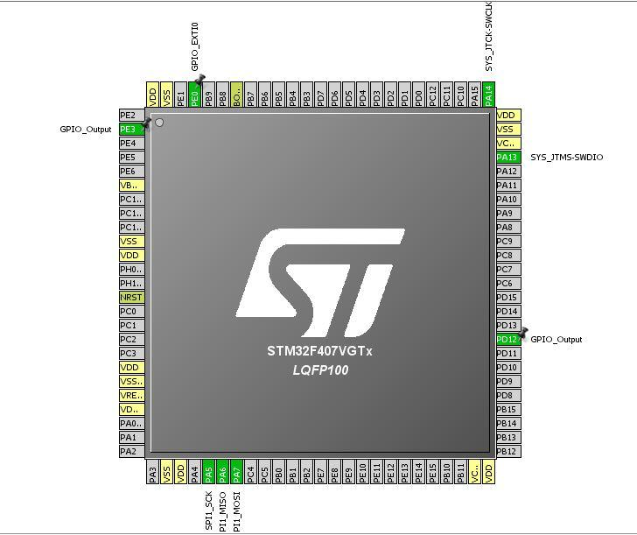

3. Click on configuration ->click on SPI1 ->make the Prescale (for Bound Rate ) as 16.

4.Click on GPIO pin configuration ->make PE3 IS HIGH.

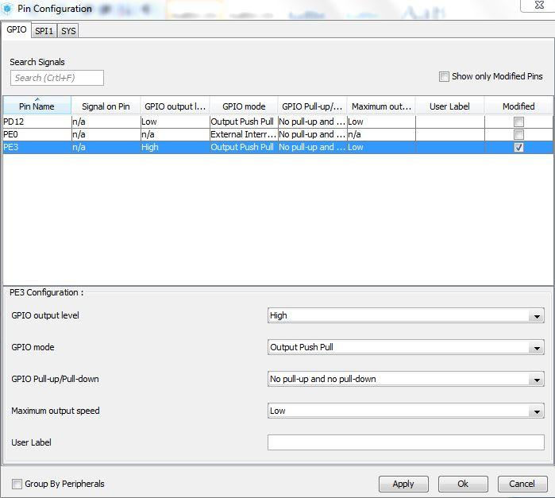

5.Click on NVIC pin configuration ->tick on EXTI line 0 interrupt.

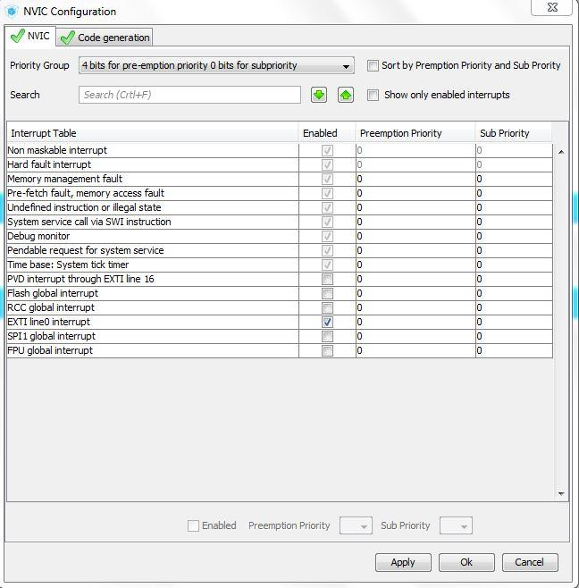

6. Then click on Apply and OK and generate code.

7. Open main.c make the following changes in code .

Define the *uint8_t TxBuf[2],RxBuf_X[2],ReturnVal[2],RxBuf_Y[2],RxBuf_Z[2]* ] in /* USER CODE BEGIN 0 */

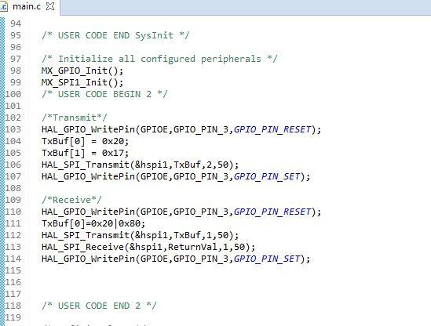

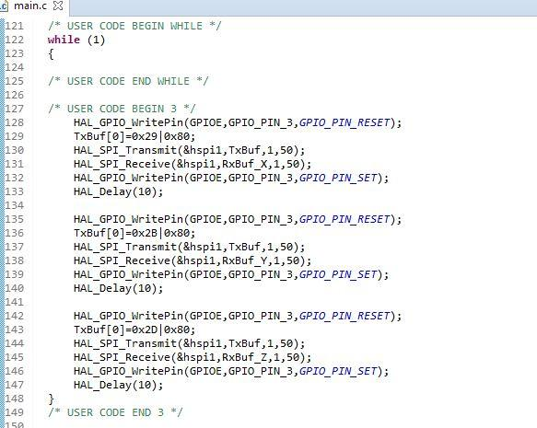

8.Build the project and Run.